

Licenciatura em Engenharia Informática

PANDORA installation guide

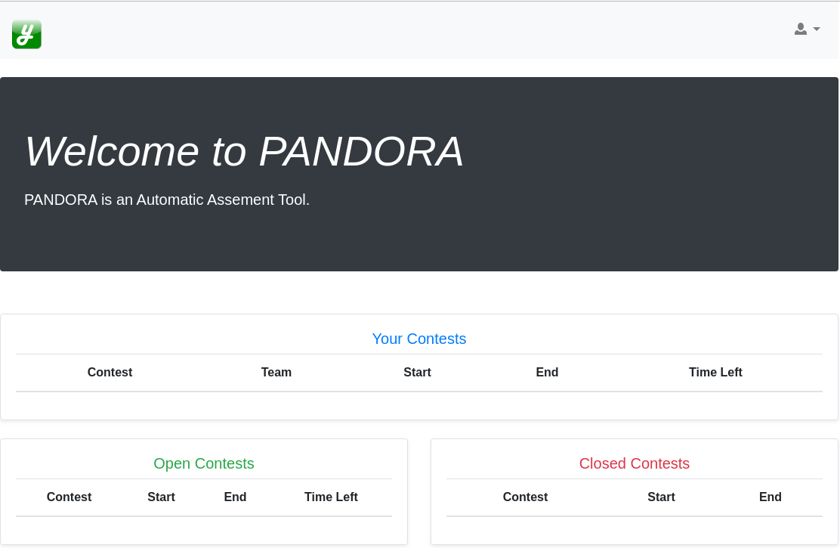

**Orientador:**Pedro A. C. B. Serra  
**Aluno:**Bruno M. D. Leal

Index

Download safeexec.zip 4

Installations necessaries 5

Install safeexec 6

Install a PANDORA instance 7

Setup MySQL 8

Setup PANDORA main user 9

Webgrafia: 10

Figures Index

Figure 1 – Download safeexec.zip 4

Figure 2 – Pandora platform 6

Figure 3 – Output of the command “unserver” 7

## Download safeexec.zip

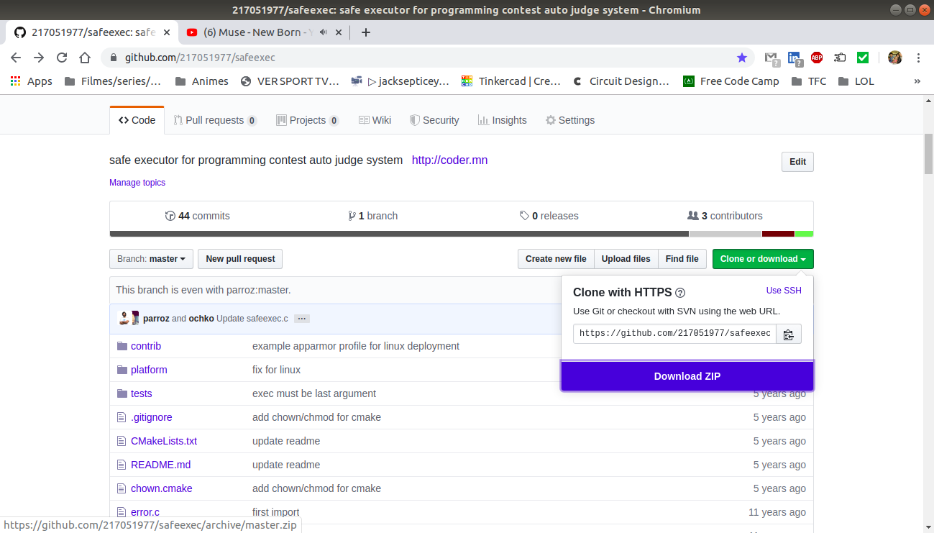For you to download the [safeexec.zip](https://github.com/217051977/safeexec) file, you must press on the button **Clone or download**, followed by pressing on the **Download ZIP**.

Figure 1 – Download safeexec.zip

## Installations necessaries

Through the Software download application, in our case we will use the Ubuntu software, you have in your Linux distribution, install two (2) IDE’s you are familiar with, one C directed, and the other python directed. In our case, we will choose Clion, like the name says, is C directed, and Pycharm, which like the name suggest, is python directed.

Now we need to install the cmake (C compiler), ruby language, pip interface, pipenv interface, git, and MySQLdb module, and for that you need to open a terminal instance and type down the following commands: **sudo apt install cmake -y → sudo apt install ruby -y → sudo apt install python3-pip -y → sudo apt install pipenv → sudo apt install git -y**.

## Install safeexec

First, we need to correct some bugs in the code. Open Clion and then press **check out from version control** → **git** → insert this URL: [**https://github.com/217051977/safeexec.git**](https://github.com/217051977/safeexec.git) -> **clone**.

After you have cloned the project you can see that in the debug window show some warnings, so to treat them we need to go to the **CmakeList.txt** file and before the line 23 add the follow command: **CMAKE_POLICY(SET CMP0037 OLD)** and reload the changes made to the file and if we take a look to the debug window we will see that this warnings are gone so let’s keep going.

If we take a look to the file safeexec.c we can see that in the line 482 is accusing a missing import, so for that we must add the command **#include "setlimits.h"** in the beginning of the file. If we take a look at the file **setlimit.c** in the lines 16 and 20 is also missing an import so we need to add to the start of the file, the command **#include "error.h"**.

Now let’s we need to open a terminal in the directory where this project is at and run the command **cmake .** → **make** → **sudo make install → sudo make permission && make test**. When you wish to stop it you just need to go to the terminal and press **CTR+C** so you can stop the server.

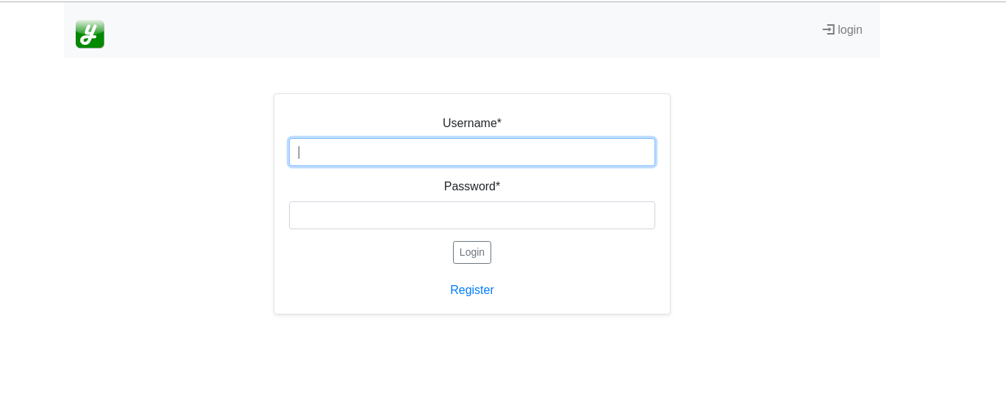Figure 2 – Pandora platform

## Install a PANDORA instance

Create a directory called “dev” in your root making you to have something like: “/home/<userName>/dev”. Then [**clone the project**](https://github.com/217051977/pandora), using the pycharm, in to this directory making you to have something like: “/home/<username>/dev/pandora”.

Inside the directory “dev” open a terminal and use the command **pipenv shell → pip3 install django → pip3 install --upgrade django-crispy-forms**.

Change the directory in the terminal to the pandora directory and then use this command **pip3 install mysqlclient**.

Now we need to go to the file **/home/<username>/dev/pandora/pandora/settings.py** and in the lines 26 to 28 we need to set the values of those variables.

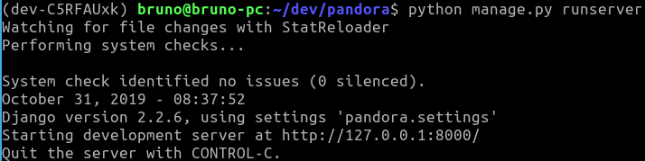If now we run our server using the command **python manage.py runserver** we will have something like this:

Figure 3 – Output of the command “unserver”

*So,* what we need to do now is copy the *URL*, [**http://127.0.0.1:8000/**](http://127.0.0.1:8000/) and paste it in your browser so you can see something like this:

## Setup MySQL

In the folder **/home/<username>/dev/** and use the command **sudo su** **→ mysql -u root -p** and you can inser anything because the root user does not have a password yet, so what we need to do, now that we are inside root mysql account, is a password so only we can enter, and for that we use the mysql command: **UPDATE mysql.user SET authentication_string = PASSWORD('new_password') WHERE User = 'root'; →** **FLUSH PRIVILEGES;**.

Now that we have our root setup, we gonna add a new user: **INSERT INTO mysql.user (User,Host,authentication_string,ssl_cipher,x509_issuer,x509_subject)** and then we add the values: **VALUES('<username>','localhost',PASSWORD('<password>'),'','','');**. After that, because we want this user to be our production user, we need to allow it to do anything in this platform and for that is used the command: **GRANT ALL PRIVILEGES ON *.* to <username>@localhost;** → **FLUSH PRIVILEGES**. Then we exit mysql setup and log out from the user “root”: **exit → exit**.

Once we have our main user to work with in the platform, we can log in with it: **mysql -u <username> -p → <password>**. The next step is adding a new schema to our databases (so we can reference our platform on it) and for that first we use the command **show databases;** so we can check the schemas that were already created before and then finally add our pandora schema, **create schema pandora → ;**, and to visualize the schema we use again the command **show databases;** followed by the command **exit**.

Now to finalize the setup we use the following commands: **python manage.py makemigrations →** **python manage.py migrate**.

## Setup PANDORA main user

In a new terminal tab, use the command **cd dev → pipenv shell → cd pandora →** **python manage.py createsuperuser → python manage.py migrate**.

Going back to the other terminal tab, for start the server use the command **python manage.py runserver**. Then when you want to shut down the server you user the command **CTR+C** and then you insert **exit** so you can exit from the shell.

## Webgrafia:

Safeexec github   
<https://github.com/217051977/safeexec>